Abstract

This project aims to identify recent characteristics across the 5 major leagues in European football, largely pertaining to goal scoring trends. Football has seen a major paradigm shift in recent years, with greater focus on measured possession play as a result of the ‘Guardiola’ revolution circa 2009 and his supreme FC Barcelona team.

This project hypothesizes that his philosophy of play has been imbibed by iterations of his team across the globe, with its hallmarks being 3 key attributes

1. Build up speed (Speed at which attacks are constructed)
2. Build up passing (Player spacing distance, promoting greater possession)
3. Defence pressure (Playing with a high defensive line to compress the opponent’s play)

This study will first investigate general goalscoring levels across the 5 leagues over time to detect any perceptible preliminary shifts in the openness of play (a measure of how direct tactics are).

This study will further evaluate trend movements in the 3 cited variables across time to assess the hypothesis.

Goalscoring levels

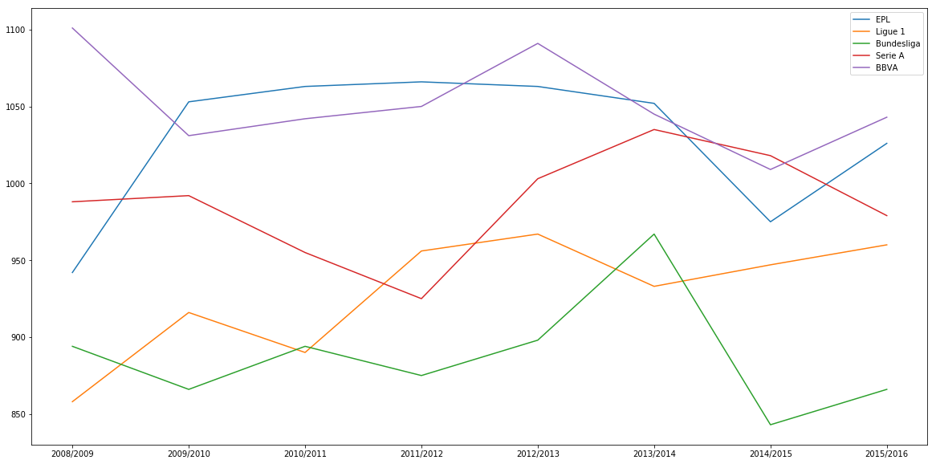

From the figure above, we see no discernible directional trends in goals scored within each league.

Next, we determine if there are significant population specific differences between the leagues that result in a more defensive/caution approach (less goals scored). To this end, we conduct a one way ANOVA of the 5 distributions.

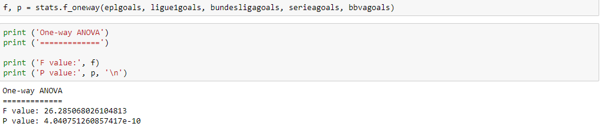

This returns a P value of 4.04e^-10, which is significantly less than our critical one way value of 0.05. This suggests that at least one of the populations has a different goals scored mean than the others.

With this in mind, we conduct a pairwise t-test with scipy to determine which leagues are scoring less goals, possibly as a result of different footballing philosophies.